**Lexar® JumpDrive® P30 USB 3.2 Gen 1 Flash Drive**

128GB

[Where to buy](https://americas.lexar.com/product/lexar-jumpdrive-p30-usb-3-2-gen-1-flash-drive/)

**Key Features:**

Up to 450MB/s read and write speeds

* USB 3.2 Gen 1 Performance
* Premium Metal Design
* Large Capacity Options
* 256-bit AES Encryption

**Key Features:**

Up to 450MB/s read and write speeds

* USB 3.2 Gen 1 Performance
* Premium Metal Design
* Large Capacity Options
* 256-bit AES Encryption

[Features](https://americas.lexar.com/product/lexar-jumpdrive-p30-usb-3-2-gen-1-flash-drive/#feature-section)[Specifications](https://americas.lexar.com/product/lexar-jumpdrive-p30-usb-3-2-gen-1-flash-drive/#specifications)[Part Numbers](https://americas.lexar.com/product/lexar-jumpdrive-p30-usb-3-2-gen-1-flash-drive/#product-numbers)[Related products](https://americas.lexar.com/product/lexar-jumpdrive-p30-usb-3-2-gen-1-flash-drive/#related-products)

**Features**

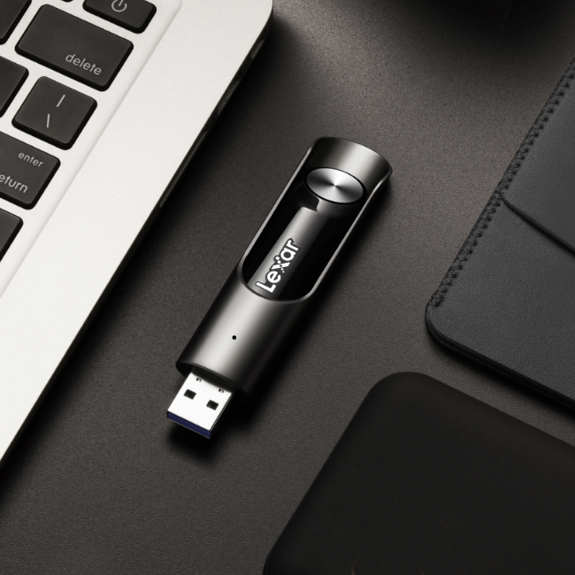

**Transfer large files with blazing fast USB 3.2 Gen 1 speed**

This sleek, portable flash drive is for professionals who want to make transferring, sharing photos, videos and large files a breeze even when on the go with blazing fast USB 3.2 Gen 1 speeds—up to 450MB/s reads and writes1. It is available in different capacities up to 1 TB to best suit your needs.

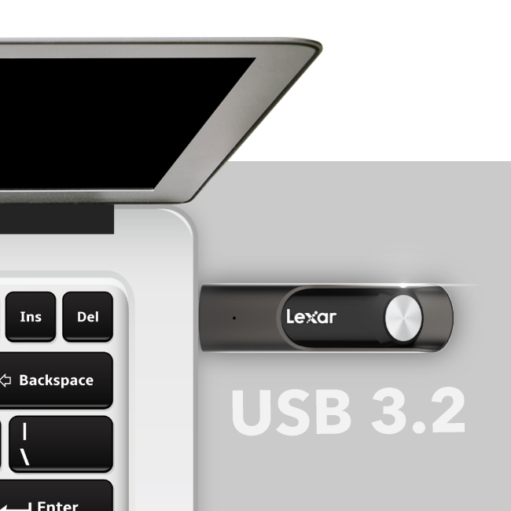

**Store and transfer files at blazing fast USB 3.2 Gen 1 speed**

With blazing fast USB 3.2 Gen 1 performance, your busy schedule won’t be delayed by spending extra time waiting for your files to transfer. This flash drive delivers speeds up to 450MB/s read / write1 so you can access your content in a split second and speed up your workflow from start to finish.

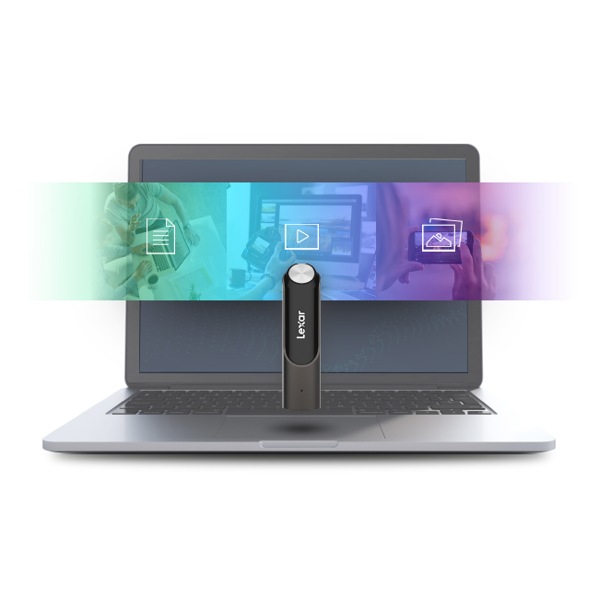

**Capacities for you to store all your data**

Find the capacity that best suit your needs as the JumpDrive P30 comes in a wide range of capacity options—from 128GB up to 1TB, so you can find the right one to store and backup all your files with ease.

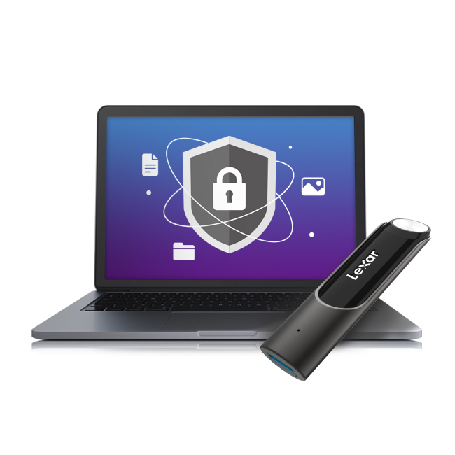

**Securely protect your files**

For professionals who are looking to protect their personal information, financial records, or other confidential files, the Lexar JumpDrive P30 comes with 256-bit AES encryption to help protect your essential files against corruption, loss, and deletion for added security. Easily create a password-protected vault that automatically encrypts data and for added peace of mind, files that are deleted from the vault are securely erased and can’t be recovered.



**Compact and durable metallic design for convenient use2**

The sleek, metallic and portable flash drive is designed for convenience and also comes with a genuine leather case for added protection. And with its plug-and-play ability, the powerful performance of the P30 is simple to use with PC, laptops and more.



**Rigorously Tested**

All Lexar products undergo extensive testing in the Lexar Quality Labs, facilities with thousands of different cameras and digital devices to ensure performance, quality, compatibility, and reliability.

**Specifications**

* Capacity

128GB

* Interface

USB 3.2 Gen 1

* Performance

Up to 450MB/s read and write speeds1

* Operating Temperature

0 °C to 60 °C (32 °F to 140 °F)

* Storage Temperature

-20 °C to 85 °C (-4 °F to 185 °F)

* Dimension (L x W x H)

78.2 mm x 21 mm x 11.8 mm / 3.07” x 0.82” x 0.46”

* Weight

32.5 g / 0.071 lbs (USB On

* System Supported

PC and Mac® systems

* Warranty

Limited lifetime warranty